**PROBLEM STATEMENT**

This aims at developing a Machine Learning Model for Traffic analysis for major ports. The Indian Railways has a capital base of about Rs. 100000 crores and is often referred to as the lifeline of the Indian economy because of its predominance in transportation of bulk freight and long distance passenger traffic. The network criss-crosses the nation, binding it together by ferrying freight and passengers across the length and breadth of the country. As the Indian economy moves into a high growth trajectory the Railways have also stepped-up developmental efforts and are preparing themselves for an even bigger role in the future at the same time it became hard to analyse traffic in major ports and our project helps to overcome that problem.

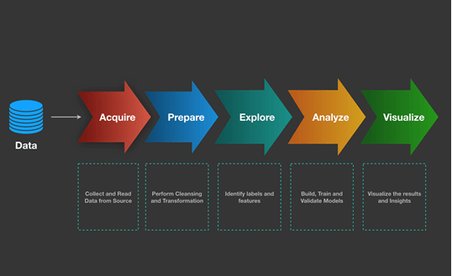**Workflow:**

|  |  |
| --- | --- |
| **QUESTION** | **DESCRIPTION** |
| Who does the problem affect? | Indian railways |
| Why is it important? | As Indian railway play major role in Indian economy it is important to analyze the traffic in major ports |
| What are the benefits? | • AI along with ML model  • Automatic Prediction  • Data Analysis |
| How is it better than the others? | Faster Processing of data with higher accuracy and optimized model. |
| When to use? | Scenario where we want to analyze the traffic in major ports. |